IntelliPaat

AWS Solutions Architect Training

Problem Statement:

You work for XYZ Corporation. Their application requires a storage service that

can store files and publicly share them if required. Implement S3 for the same.

Tasks To Be Performed:

1. Create an S3 Bucket for file storage.

2. Upload 5 objects with different file extensions

------------------------------------------------------------------------------------------------------------------------------

Go to S3 Bucket Service

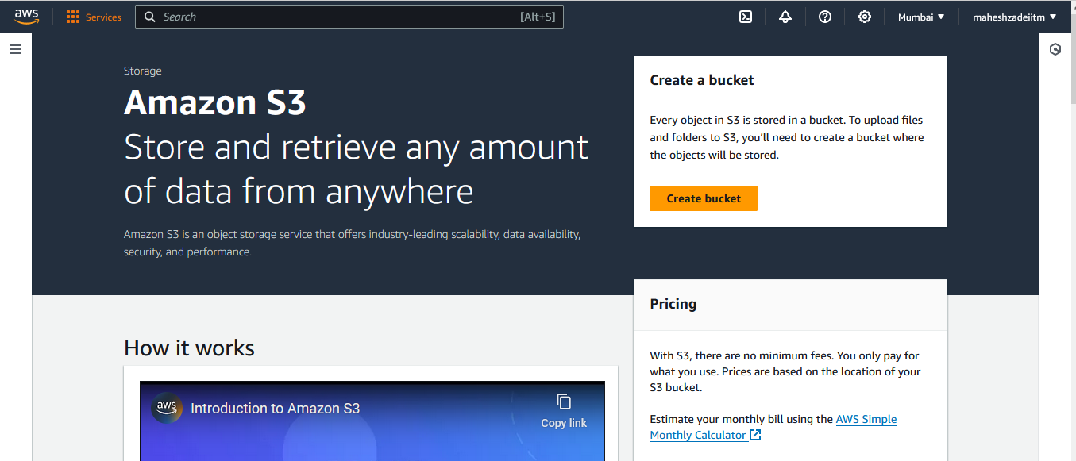

Click on Create Bucket

Give your unique name and leave all the options as it is and Create

Give the Bucket Name

Unchek block public Access

Check Acknowledge

Keep the below settings as it is and click on create bucket

Bucket is created

Select the Bucket

Go to the bucket choose upload >> Add files >>> upload any 5 files with diff extensions >>> Save

Uploaded 5 file with diff extensions

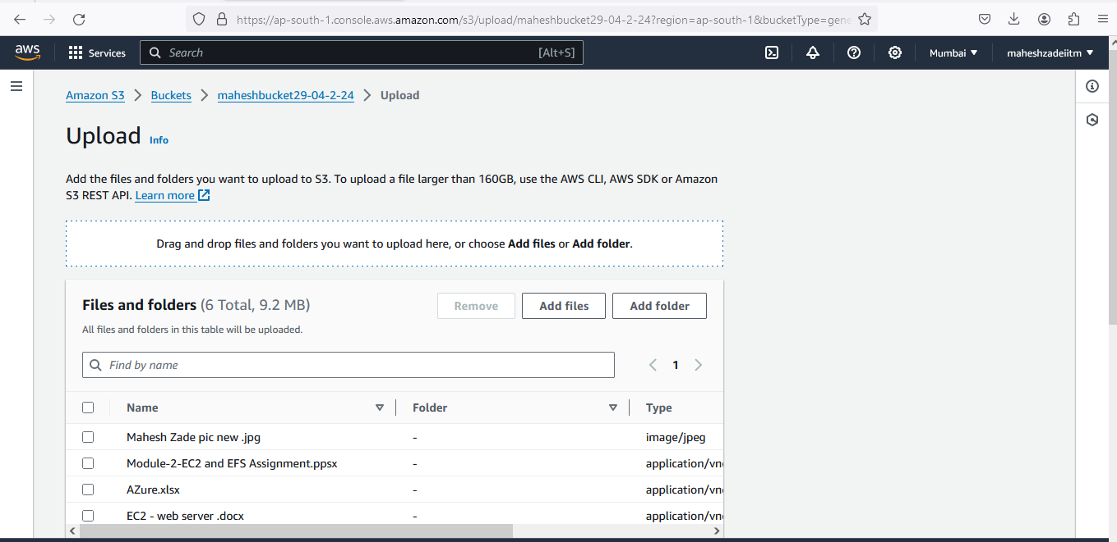

Go the Bucket >>> Permissions >>>> Uncheck >>> Block all public access and try to refresh that URL and see if that is accessible? if not follow the below steps

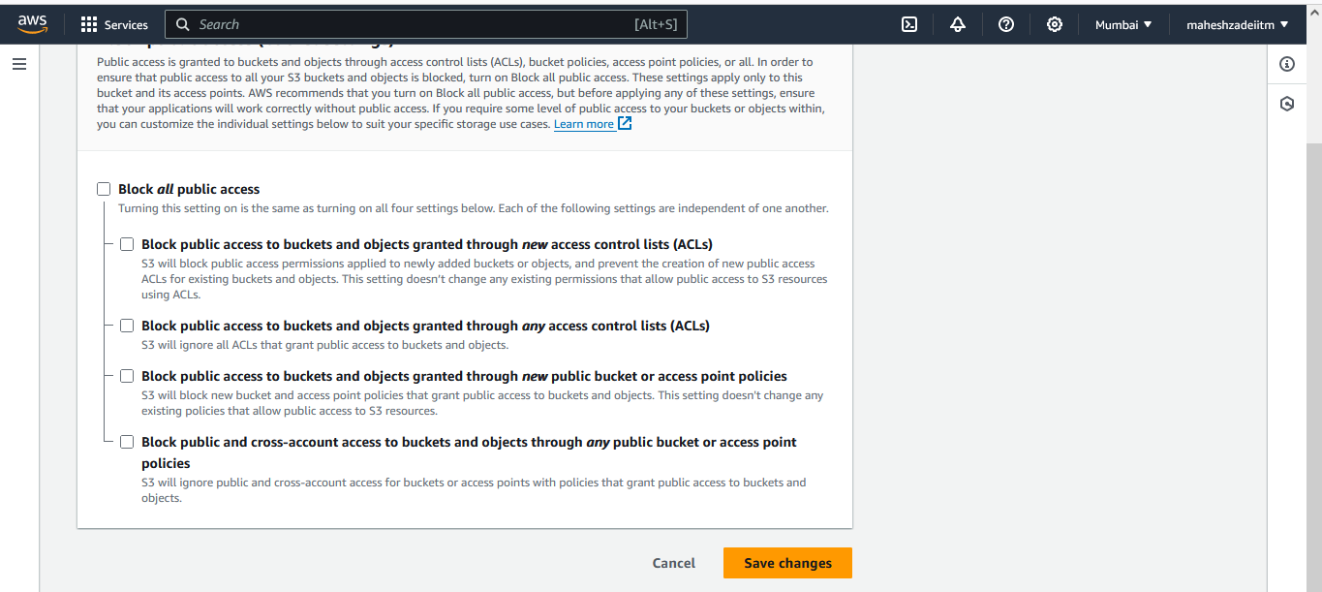

Confirm

Go the Object >>> Permissions >>> you can see Edit button is not editable, then click on "bucket owner enforced" and >>>>> Edit Object Ownership >>>> ACLs enabled

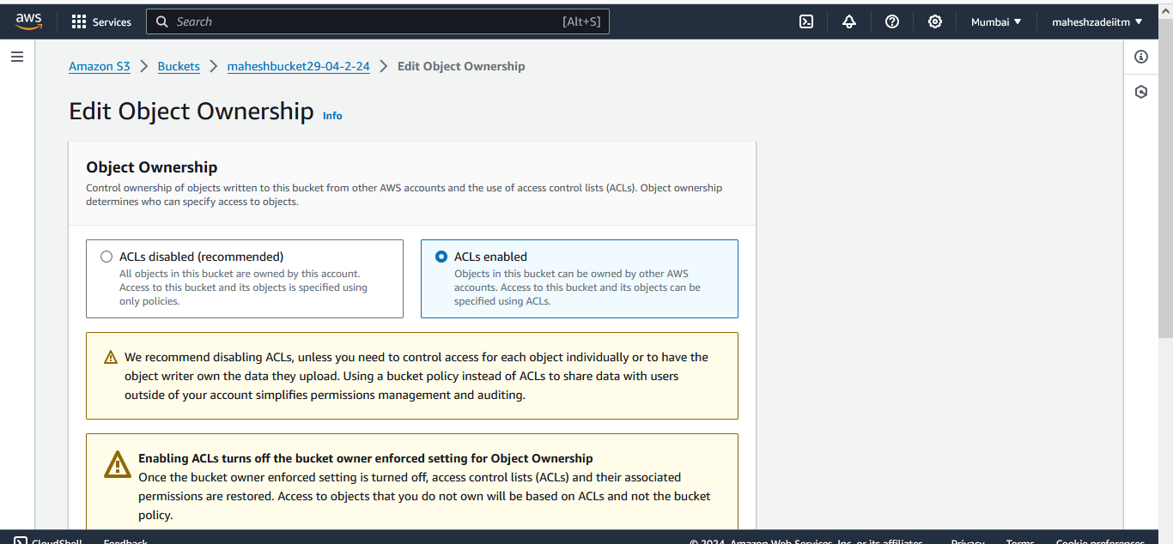

This bucket has the bucket owner enforced setting applied for Object Ownership

When bucket owner enforced is applied, use bucket policies to control access. Learn more

bucket owner enforced >>>>> Edit Object Ownership >>>> ACLs enabled

I acknowledge that ACLs will be restored.

Save Changes

Now you can see EDIT

Edit

Choose Everyone (public access) >>> Read && Write

I understand the effects of these changes on this object.

Now you can try to refresh that URL and see if that is accessible >>> it should work

Try to disable that permissions one after other at bucket level and object level.

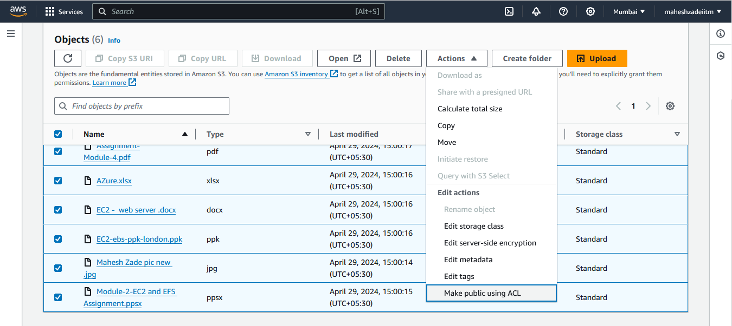

Clik on make public

Copy the object url

<https://maheshbucket29-04-2-24.s3.ap-south-1.amazonaws.com/Assignment-Module-4.pdf>

Paste in the browser

<https://maheshbucket29-04-2-24.s3.ap-south-1.amazonaws.com/AZure.xlsx>

<https://maheshbucket29-04-2-24.s3.ap-south-1.amazonaws.com/EC2+-++web+server+.docx>

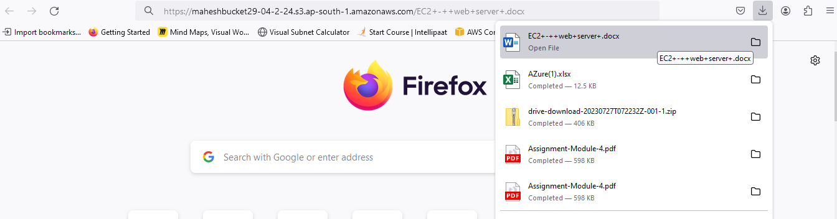

<https://maheshbucket29-04-2-24.s3.ap-south-1.amazonaws.com/Mahesh+Zade+pic+new+.jpg>

<https://maheshbucket29-04-2-24.s3.ap-south-1.amazonaws.com/Module-2-EC2+and+EFS+Assignment.ppsx>

LMS S3 bucket created and 5 diff file uploaded in the bucket

Pls check the Assignment and confirm .